State Pension Contribution Comparison

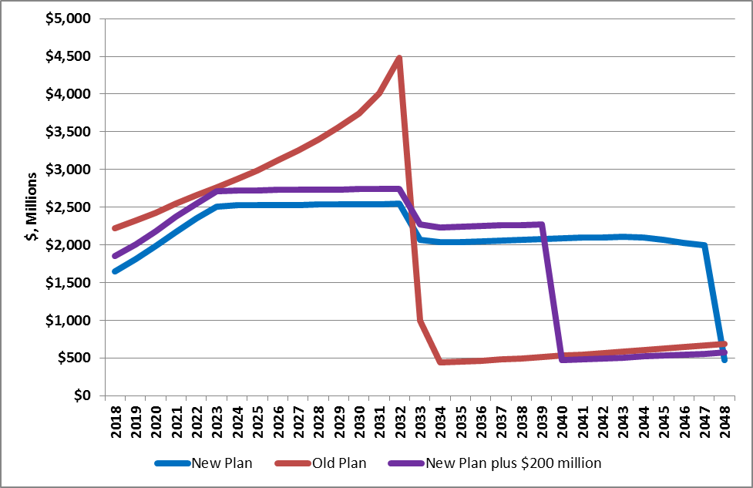

Reinvesting $200 million of union concession savings
each year reduces future additional costs
to taxpayers from $11 billion to $3 billion.

