Saving State Pensions
(in millions of dollars)

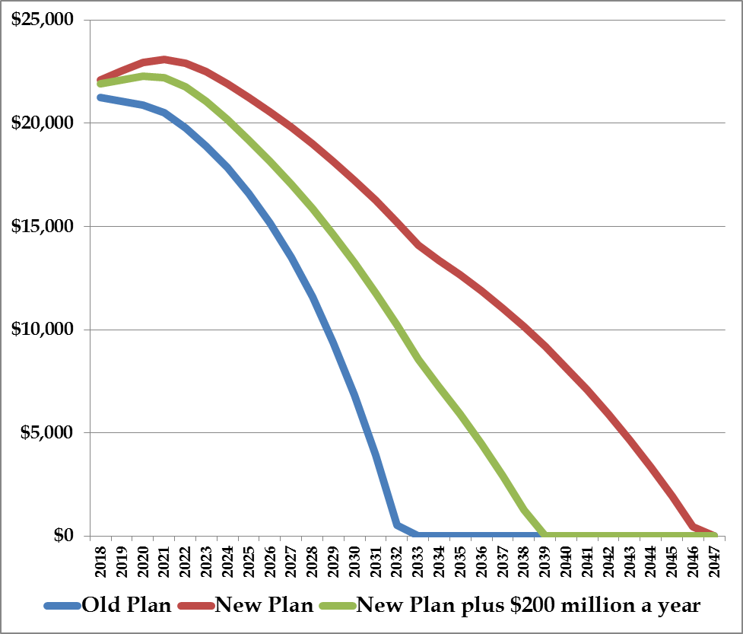
New Plan
Old Plan
Alternative

Comparison of Unfunded Liability Reduction

Reinvesting $200 million of union concession savings each year cuts the time to pay off unfunded liability by seven years.

